Q1.

1. User Stories in the system are sensing of the temperature, humidity, motion, and soil moisture through the sensors.
2. Sensing in the system is of the data of the air temperature, humidity, motion and soil moisture.
3. Thinking in the system is of the data collected by sensors which will be displayed on the screen through the programming and displayed in well-mannered way.
4. Acting in the system is the data displayed of the appropriate things.

Q2.

1. Serial.begin (9600) refers to the Arduino transmitting speed will be 9600 bits per second which is by default.
2. It will take 0.02 seconds to transmit the data.
3. To check the program working, I open the serial monitor and check the status of Active and Inactive by doing a motion or not doing the motion.

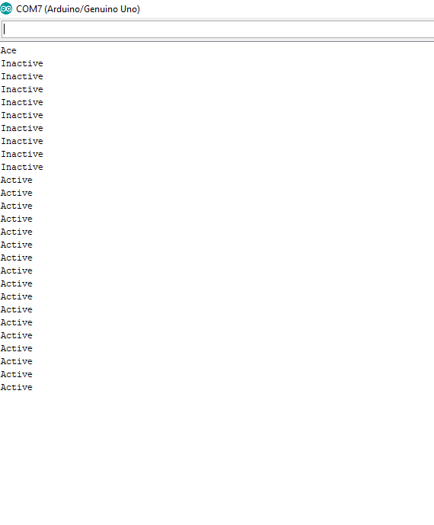

1. Here is the Link of the Data Log of the Motion Sensor:

<https://github.com/jasmeetsi4/Sensors-data/blob/master/2_2%20Motion.txt>

Q3.



|  |  |  |
| --- | --- | --- |
| Term | Explanation | Example Usage from code |
| Variable | A variable is place for storing some sort of data which has name, value and type. | Float temp; |
| Library | Library is a set of code which will help to use some other types of sensors. | #include<DHT.h> |
| Comment | Comment is “//” in the code which is used for understanding purpose and is applied so that developer knows what happens at that point | //Library Files |

1. i) Sampling Rate is the rate which defines that how the data will collected as in DHT22 sampling rate is 0.5 Hz which means 1 reading after every 2 second.

ii) It is used in loop function where reading is made and after that there is delay (2000) which makes the DHT22 sensor to collect the readings after 2 seconds.

1. To test this program there is Serial.print() function which will print the data on the serial monitor and through which we can check the Humidity and Temperature reading. Checking the wires connected and COM port is also a part of testing.
2. Proof of the Serial Monitor Displaying the Temperature and Humidity data logs.

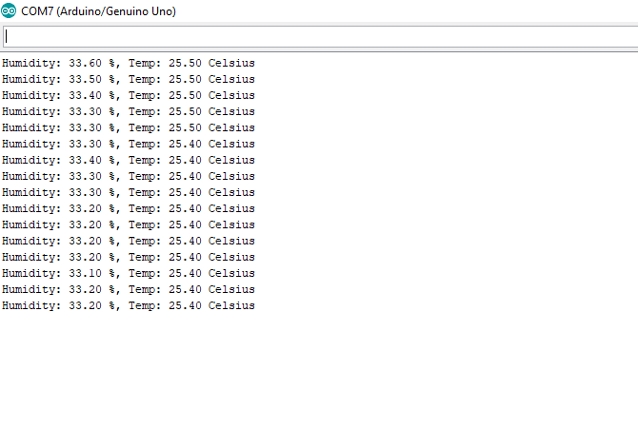

1. Link of the Data gathered:

<https://github.com/jasmeetsi4/Sensors-data/blob/master/2_2%20Temperature%20and%20Humidity%20Data.txt>

Q4.

1. analogRead(0) reads a analog value from the pin 0 of the analog sensor or data.
2. analogRead () is used for reading the analog values like in the soil moisture there is reading of the analog values of the moisture but in the digitalRead() it is used for a digital signal like connecting the LED’s and other button signal like tasks.
3. For testing the program I used two tissues one wet and other is dry where in wet the moisture is high and depict the value higher and in the dry tissue case the value of the moisture is lower which depicts it is lower.

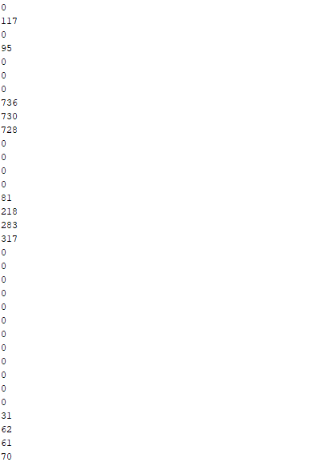

1. Here is the Link of the data of the Moisture Content:

<https://github.com/jasmeetsi4/Sensors-data/blob/master/2_2%20Moisture%20Data.txt>